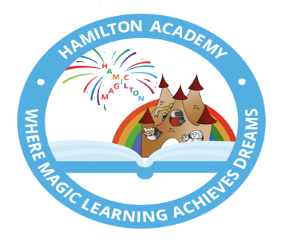

HAMILTON ACADEMY
DIARY DATES Summer 2023
Monday 17th April 2023 | School reopens  Welcome back!  Please remember that children need to bring into school a water bottle and school book bag. School Fund of £1.00 per week should be paid via Parent Pay to help with our fundraising towards our playground development.  Please be reminded that all personal belongings need to be clearly labelled with your children’s name.
Monday 1st May 2023 | Bank holiday  Our Academy will be closed on this day for May Bank Holiday.
Monday 8st May 2023 | Bank holiday  Our Academy will be closed on this day.  Bank holiday for the coronation of King Charles III.
Monday 8th May – Friday 19th May 2023 | SATS  Our Year 2 children will be undertaking the statutory Key Stage 1 Maths and Reading assessments. Please ensure that your child is in school on time every day, it is a statutory requirement that all children undertake these assessments.
Tuesday 16th May 2023 | Academy Photographers in school.  Year 2 - Class photographs/individual children  Nursery, Reception and Year 1 - Class photographs  Please note – these sessions do NOT include family or sibling photos.
Thursday 18th May 2023 | Special Lunch Menu  Children are welcome to join us for a special school meal. No need to bring in a packed lunch today! Please see our school website for more information.
Tuesday 23rd May 2023 | Sports Day  Sports Day will be taking place this year at Northwood stadium.  Parent / carers are invited to join us at 1.00pm for a prompt start.  Get your trainers ready as we may do a parent’s race!
Thursday 25th May 2023 | Nursery Ugly Bug Ball  To end the topic about mini beasts, Nursery will be holding an Ugly Bug Ball.  Children will be invited to come to nursery dressed as a mini beast. The children will take part in a special tea party and dance.
Thursday 25th May 2023  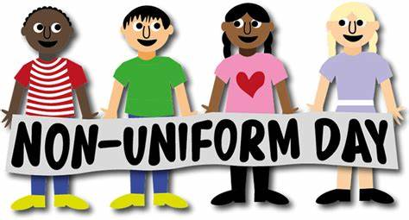 | Non-Uniform Day  Children are invited to come to school wearing non-uniform on this day (Nursery will be mini beasts)  We will be asking for donations for the forthcoming summer fayre: -  Nursery and Reception: Individually wrapped sweets / little sweet bags  Year 1: Cakes (no home-made or fresh cream please)  Year 2: Any type of bottle for our tombola
Friday 26th May 2023 | School Closed  School closes at the end of the school day on Thursday 25th May 2023 for half term.
Monday 5th June 2023 | School Reopens  Welcome Back!  School reopens on Monday 5th June 2023.
Thursday 8th June 2023  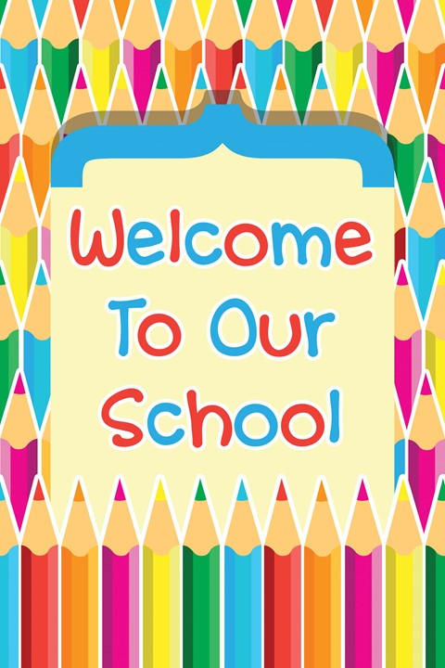 | Welcome Event  An opportunity for prospective families to visit the academy and meet the staff.  Information will be shared on the induction process.  This event is taking place in the school hall from 4.30pm until 5.30pm.
Monday 12th June – Friday 16th June 2023  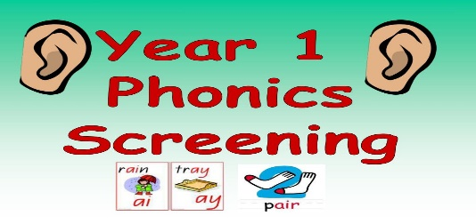 | Year 1 Phonics Screening.  Children will be undertaking the statutory Phonic Screen.  Please ensure that your child is in school on time every day, it is a statutory requirement that all children undertake the Phonic Screen assessment.
Monday 12th June 2023  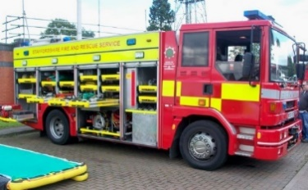 | Fire Service Assembly  Following on from their topic last half term, Reception will be having an exciting visit from a firefighter who will be bringing the fire engine! The children will re-cap the learning and get to experience how the fire engine works in real life!
Friday 16th June 2023  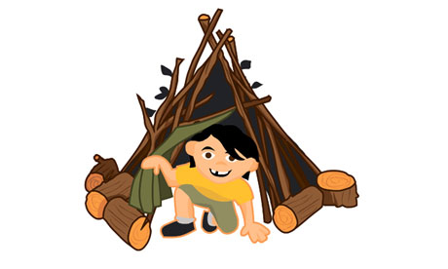 | Nursery Father’s Day forest School Den Building Session.  For Father’s Day, Nursery will hold a Forest School Den building session. Special men will have an opportunity to explore the Forest School area and complete a den building session with their child.  There will be two sessions 9-10am and 1.30-2.30pm so no child will miss out.
Monday 19th June – Friday 23rd June 2023 | Virtual Book fair  An opportunity for parents to purchase books at great prices from our online book fair.
Wednesday 28th June 2023 | Summer Fayre  We are excited to be bringing back our summer fayre. There will be lots of exciting stalls and games to get involved with. It will be a lovely family event and we urge you all to join us for some fun and games after school.
Wednesday 5th and Thursday 6th July 2023 | Bump up Day  Children will spend these two days in their new class or their new schools.  We are very excited that our Year 2 children will be going to Grove Junior School for these two days.  More information will be communicated closer to the time.
Tuesday 12th July 2023  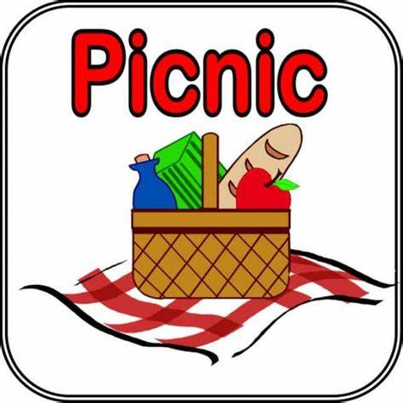 | Y2 Buddy Leavers Picnic at Forest Park  The year 2 children will enjoy a picnic at Forest Park on this day, I’m sure we will play some games and have lots of fun.
Friday 14th July 2023 | School Reports  Children will be coming home with their reports today.  Please read and enjoy, and celebrate with your child their achievements this year.  Please also take the opportunity to complete the comments page and return this to school. We really do value your feedback and support.
Monday 17th July 2023  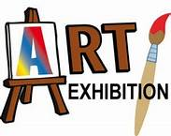 | Nursery Art Exhibition  To celebrate the children’s end of year achievements, Nursery will hold an art exhibition in the school hall. The children will get to showcase their work to their grown-ups and have some refreshments whilst they talk about what they have done and the work they are most proud of.
Wednesday 19th July 2023  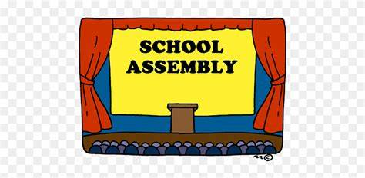 | Year 2 Leavers Concert  Our Year 2 children will be performing their amazing end of year leavers’ concert.  This is always a very enjoyable event that celebrates all the children’s achievements and development since joining our school.  We really do hope that all the year 2 parents / carers can join us for this celebration at 9.15am.
Friday 21st July 2023 | Magic Day  To celebrate the hard work, commitment and achievements of our children all children and staff will be taking part in our ‘Magic Day’. This will be a day of celebration though different activities throughout the day.
Friday 21st July 2023 | Academy closes to all  School closes at the end of the school day on Friday 21st July 2023.
Tuesday 5th September 2023 | Academy Reopens  Welcome back!  Please remember that children need to bring into school a water bottle and school book bag. School Fund of £1.00 per week should be paid via Parent Pay to help with our fundraising towards our playground development.  Please be reminded that all personal belongings need to be clearly labelled with your children’s name.

