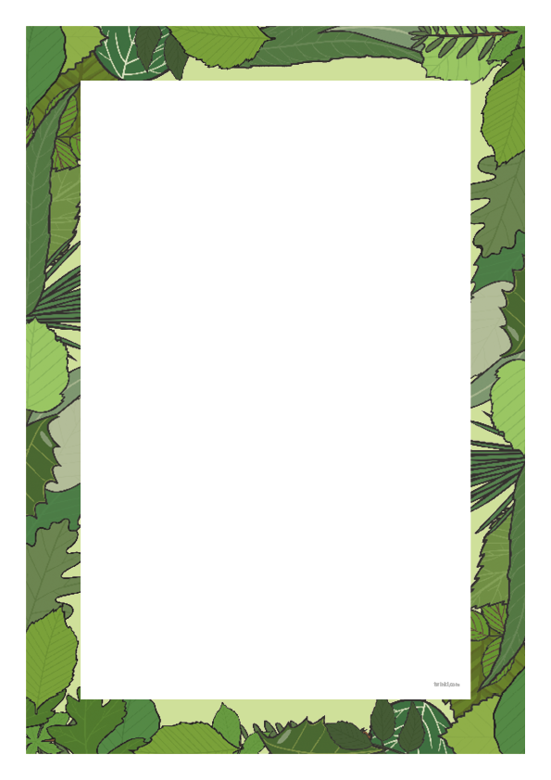
The Jungle Song by Paul Shelley

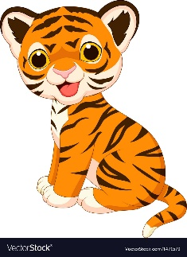
Tiger, tiger, orange and black,
He’s got stripes upon his back.
When he growls, sharp teeth I see,
He’s as scary as can be!
Tiger, tiger, orange and black,
He’s got stripes upon his back.
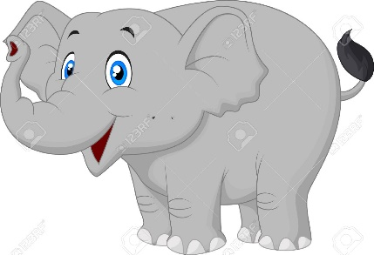
Elephant, elephant, large and grey,
Swings his trunk along the way.
His ears are big, his tusks are white,
Don’t be scared, he doesn’t bite!
Elephant, elephant, large and grey,
Swings his trunk along the way.

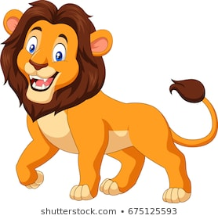
Lion, lion, mighty and strong.
With a very loud road and a mane so long.
A lioness has no mane.
A cub is a baby lion’s name.
Lion, lion, mighty and strong.
With a very loud road and a mane so long.

