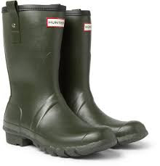

**Wild Wednesday**

May we remind you that children need to bring in extra clothes for Wild Wednesday each week. These should be suitable for the weather and include a pair of wellingtons. Children with waterproof all in one suits will be able to take part in mud sliding!

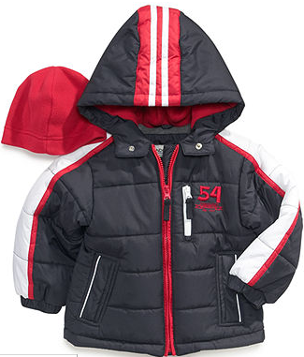

**PE Kits**

PE will continue to take place on Friday. Please ensure that your child brings their PE into school on the first day back after each half term. PE kits will be sent home at the end of each half term to be washed.

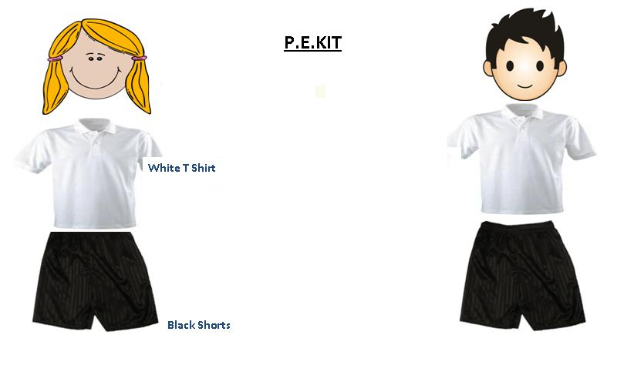

Don’t forget…

All items of clothing need to be clearly labelled with names.

**Vocabulary**

Key vocabulary that we be learning this term. Ask your child to show you or tell you what each word means.

*snarled, first, second, third, decided, arrived, eventually, once upon a time, next, as soon as, after, one day, suddenly, beanstalk, harp, grow, pant, seed, castle, giant*

Dalmatians LW

Summer Term

**Homework**

Homework will be set every Wednesday and will be live until the following Monday. Please support your child to complete their homework as it allows the children to apply what they have been learning at school.

<https://ec1.educationcity.com/?_ga=2.122751945.358373069.1552496471-438602286.1543237139>

**Half Termly Challenges**

This term the homework challenges are;

|  |  |
| --- | --- |
| Summer 1 | The children have been learning about planting. Can you grow something at home and observe the changes?  Create a diary – drawing and writing about the changes that occur. |
| Summer 2 | The children will be baking Gingerbread Men. What can you bake together at home?  Bring in photograph to show us what you have made. |