Unique

It’s hard to be different,
To act just like you.
To love your uniqueness,
In whatever you do.

Your hair can be curly,
Or wavy or straight,
Your eyes might be different,
But that makes you great.

Running or writing,
Numbers or art,
Your friends will all love you,
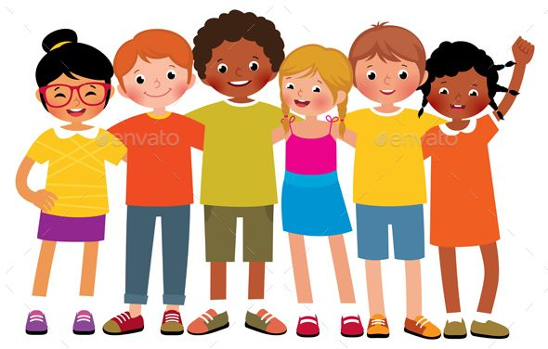
For the size of your heart.

Paula Smith

