

**Nursery Summer Newsletter 2019**

**Welcome back. We hope you have had a lovely Easter break. We have a very busy term, packed full of exciting learning opportunities for the children.**

[](https://www.google.co.uk/url?sa=i&rct=j&q=&esrc=s&source=images&cd=&cad=rja&uact=8&ved=2ahUKEwjCoqzS8a7hAhUuUBUIHdfECn0QjRx6BAgBEAU&url=http://www.landsend.co.uk/Sale/Kids/Girls/Coats_Jackets/ix-12216&psig=AOvVaw2F1qMVKj-MSB7ooe6Q1L0H&ust)[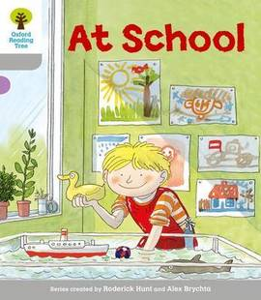](https://www.google.co.uk/url?sa=i&rct=j&q=&esrc=s&source=images&cd=&cad=rja&uact=8&ved=2ahUKEwj-l5ee8K7hAhWLVxUIHSHiBVkQjRx6BAgBEAU&url=https://www.thebookpeople.co.uk/webapp/wcs/stores/servlet/qs_product_tbp?productId%3D551325%26catalo)[](https://www.google.co.uk/url?sa=i&rct=j&q=&esrc=s&source=images&cd=&cad=rja&uact=8&ved=2ahUKEwjhy7PO767hAhWHRhUIHTvoD9AQjRx6BAgBEAU&url=https://www.amazon.co.uk/Polar-Gear-Tritan-Bottle-Turquoise/dp/B07284YBC3&psig=AOvVaw0lw1vRKrJBztULiiLnzCV)[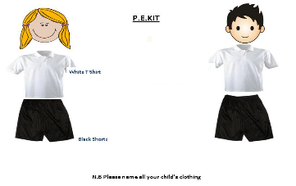](https://www.google.co.uk/url?sa=i&rct=j&q=&esrc=s&source=images&cd=&cad=rja&uact=8&ved=2ahUKEwjY5NOY8a7hAhUEUBUIHSrWCwgQjRx6BAgBEAU&url=http://www.thurcroftinfant.co.uk/pe/&psig=AOvVaw1DqkiMAAbeP2xXik3g7oVy&ust=1554207733436784)

**Things your child needs to bring into school every day.**

**English speaking board**

**Is designed to improve communication by developing speaking and listening skills. We will be continuing to share and learn different action rhymes and songs.**

**Our two rhymes will be:**

**Summer 1- The little seed**

**Summer-2 – There’s a spider on my knee**

**Sun Protection- Hopefully we will enjoy lots of sunshine this term. Please ensure that your child comes to school with a sun hat and that you apply sun cream prior to them coming to school on sunny days. Sun cream can be sent into school so that it can be applied.**

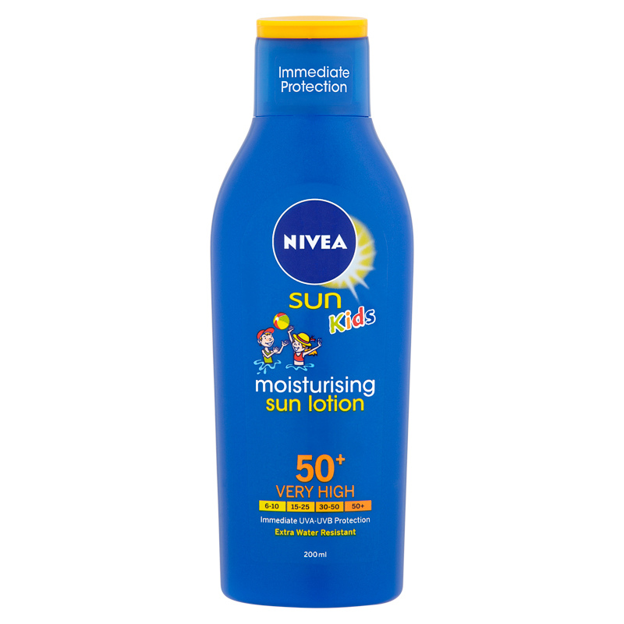 

**“If you can dream it then you can do it! Now, go out there and change the world”**

**Dates for your diary.**

**2.5.19—One Book One School launch**

**6.05.19—Bank Holiday**

**10.5.19 — Class photos**

**17.6.19 Ugly Bug Ball**

**21.5.19 Disney fancy dress day**

**23.05.19—Sports Day**

**Zoo Lab- TBC**

**8.6.19 Transition week**

**18.7.19 Magic day**

**19.7.19 School closes 12.20pm**

**During the next half term our new topic is going to be:**

**‘Changes’**

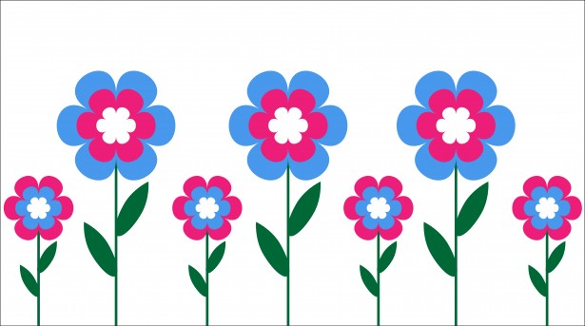

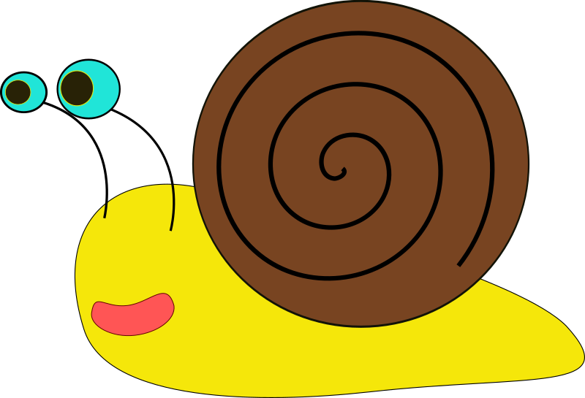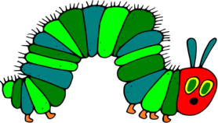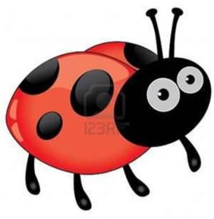

**This term we will be learning to:**

**· Read relevant stories.**

**· Grow our own sunflowers, cress beans and salad vegetable.**

**· Discover all about growing and mini beasts.**

**· Explore changes in ourselves and lifecycles.**

**· Be explorers as we investigate our environment and natural surroundings,**

**· Look for signs of Spring/Summer and go on a bug hunt in the nursery garden.**

**·   Vote as a school for a book to base our learning on for the final four weeks. We look forward to sharing with you what text we will be focusing on.**

**All children need to have a PE kit in school at all times. Please ensure all clothing is clearly labelled and PE kits are in a cordless bag.**

**PE - Wednesdays**