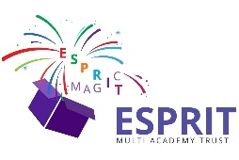
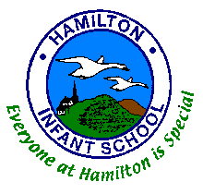
Hamilton Academy

Exciting news! If your child turned 3 years old before 31st December 2017, they are eligible to start in our nursery now. If your child is 3 years old between 1st January 2018 & 31st March 2018, they are eligible to start in our nursery in April 2018.
Why not come along to our open evening on Tuesday 13th March 2018 between 3:30pm - 4:30pm or
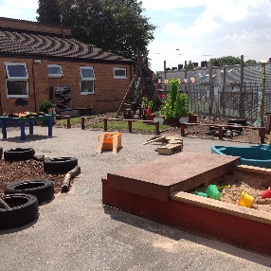
5:00pm - 6:00pm and find out more about our outstanding Early Years provision where MAGIC learning takes place every day!
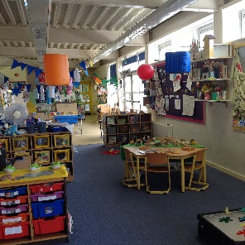
Places are also still available for a September 2018 start.
Child Centred Ethos

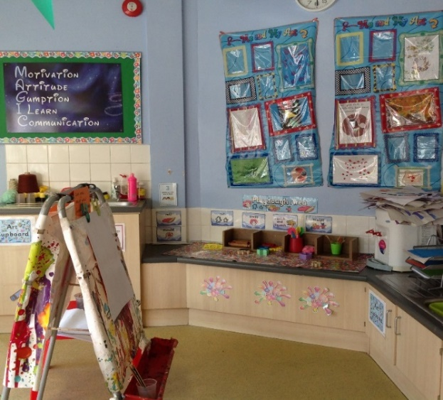

Breakfast Club from 7:30am

A, B, C
To arrange a visit or to find out more:

01782 234420
hamilton@espritmat.org

1, 2, 3

After School until
6:00pm

Outdoor Learning
http://www.hamilton.stoke.sch.uk/
Find us on Facebook and Twitter

